Sanborn Regional Middle School
Tuesday, February 18, 2020 ~ Today is a “D” Day
This week is Spirit Week which culminates in Winter Carnival Activities on Friday!

Wednesday: Sports Day
Thursday: Crazy Hair Day
Friday: Wear your colors ~ Team Blue ~ Team White ~ Team Gray

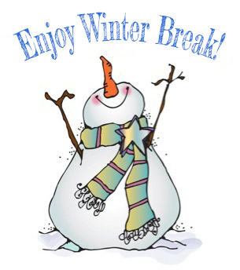

February 24 - 28

See you in March!

- AFTER-SCHOOL ACTIVITIES

DATE | February 18  Tuesday | February 19  Wednesday | February 20  Thursday | February 21  Friday | February 24  Monday  ~  February 28  Friday
Clubs and Activities | Intramurals  2:25-3:25  Robotics Club  2:30-4:30 | Jazz Band  4:00-5:30 SRHS | Intramurals  2:25-3:25

DATES TO KEEP IN MIND

